Quantitative Portfolio Analysis Project
PART 1:
Select 10 U.S. publicly listed stocks:
We have selected the following: Apple Inc., Microsoft Corporation, Alphabet Inc., Amazon.com, Inc., Tesla, Inc., NVIDIA Corporation, Meta Platforms, Inc., Advanced Micro Devices, Inc., Procter & Gamble Company, Visa Inc., SPDR S&P 500 ETF
Download the last 5 years of data, on a monthly frequency.
Compute the monthly log-returns
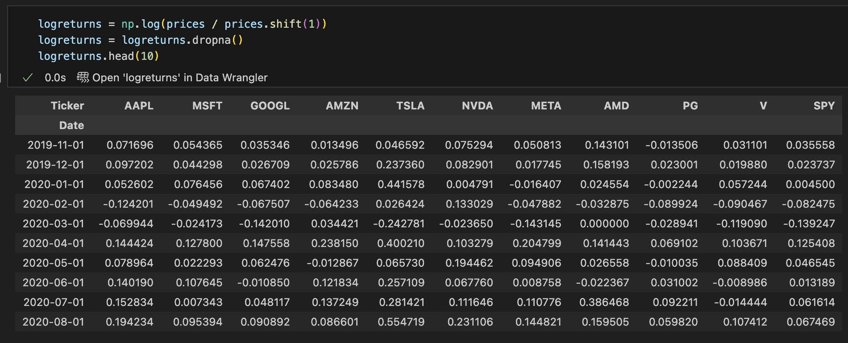
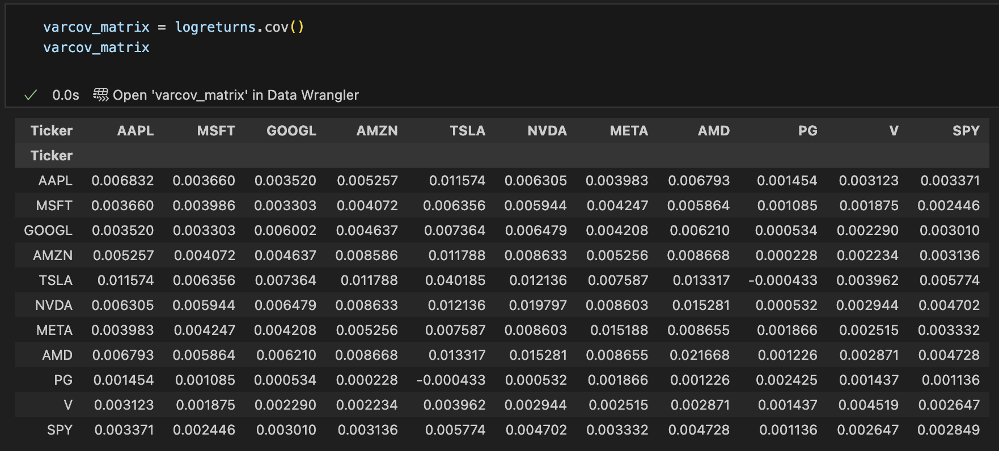
Construct the variance-covariance matrix of the returns
Compute the alpha and beta of each stock using CAPM. Use the SPY as the market index. Compare the beta you obtained to that in yahoo finance to check
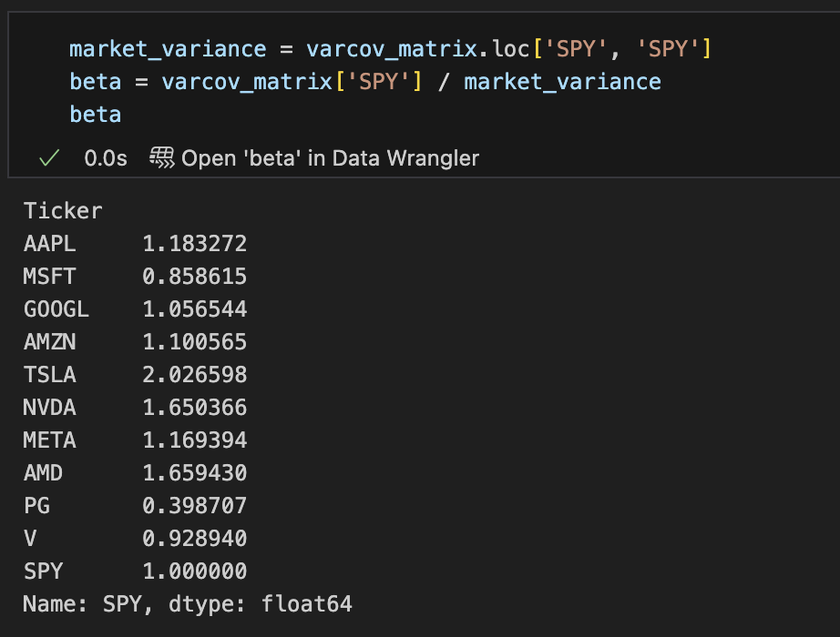
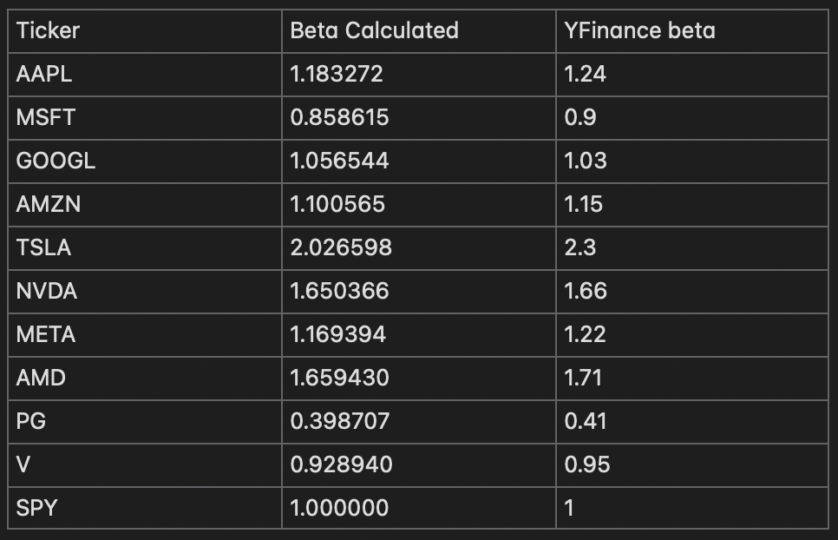
Is the alpha statistically significant at the 95% confidence level? Discuss.
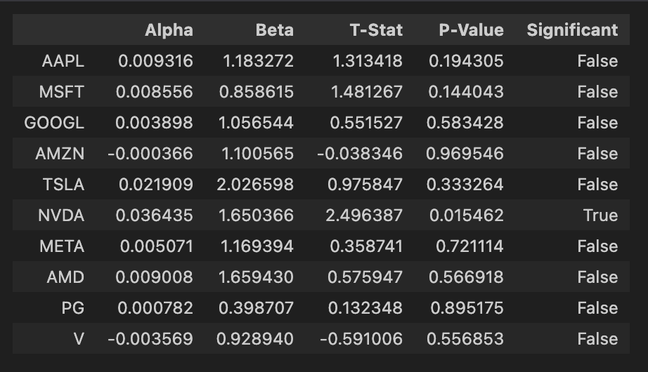
For most of the stocks the alpha is not significant at the 95% confidence level. This means that for most stocks, the alpha is due to random noise and not due to some information captured during linear regression. Only NVDAs alpha is significant at the 95% level.
SMB, HML, and MOM to the regression. Discuss how this changes alpha.
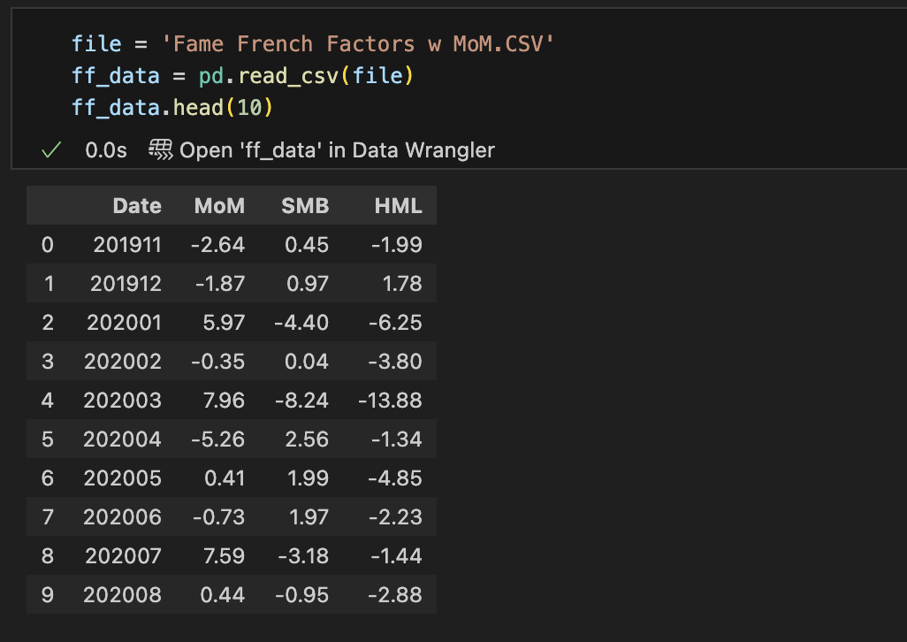
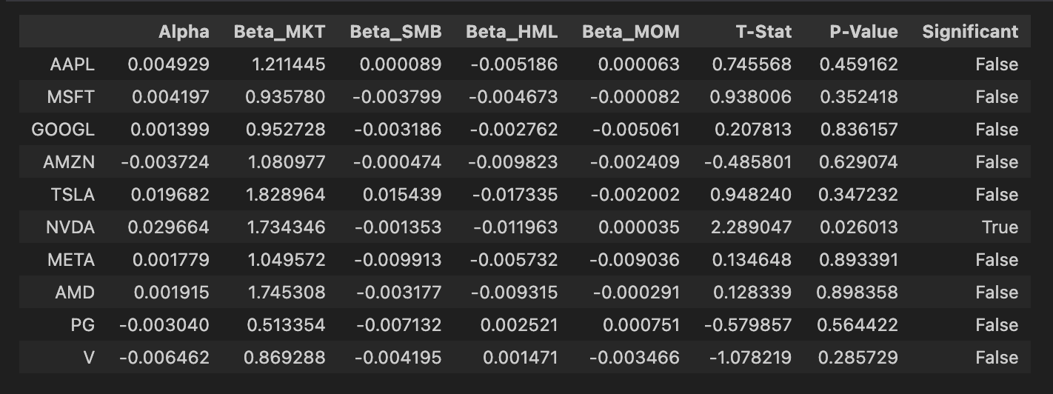
Adding Fama French Factors changes the alpha significantly. The addition of additional factors to the linear regression analysis changes the alpha estimates due to size, value and other momentum characteristics. Although there is a change in alpha, most stocks except NVDA is still not significant at the 95% level.

Using the alpha from 8) and the tracking error, compute the weights of the single index
model. You should provide a set of weights for the active portfolio, the passive portfolio
and the weight of the active and passive on the overall portfolio.
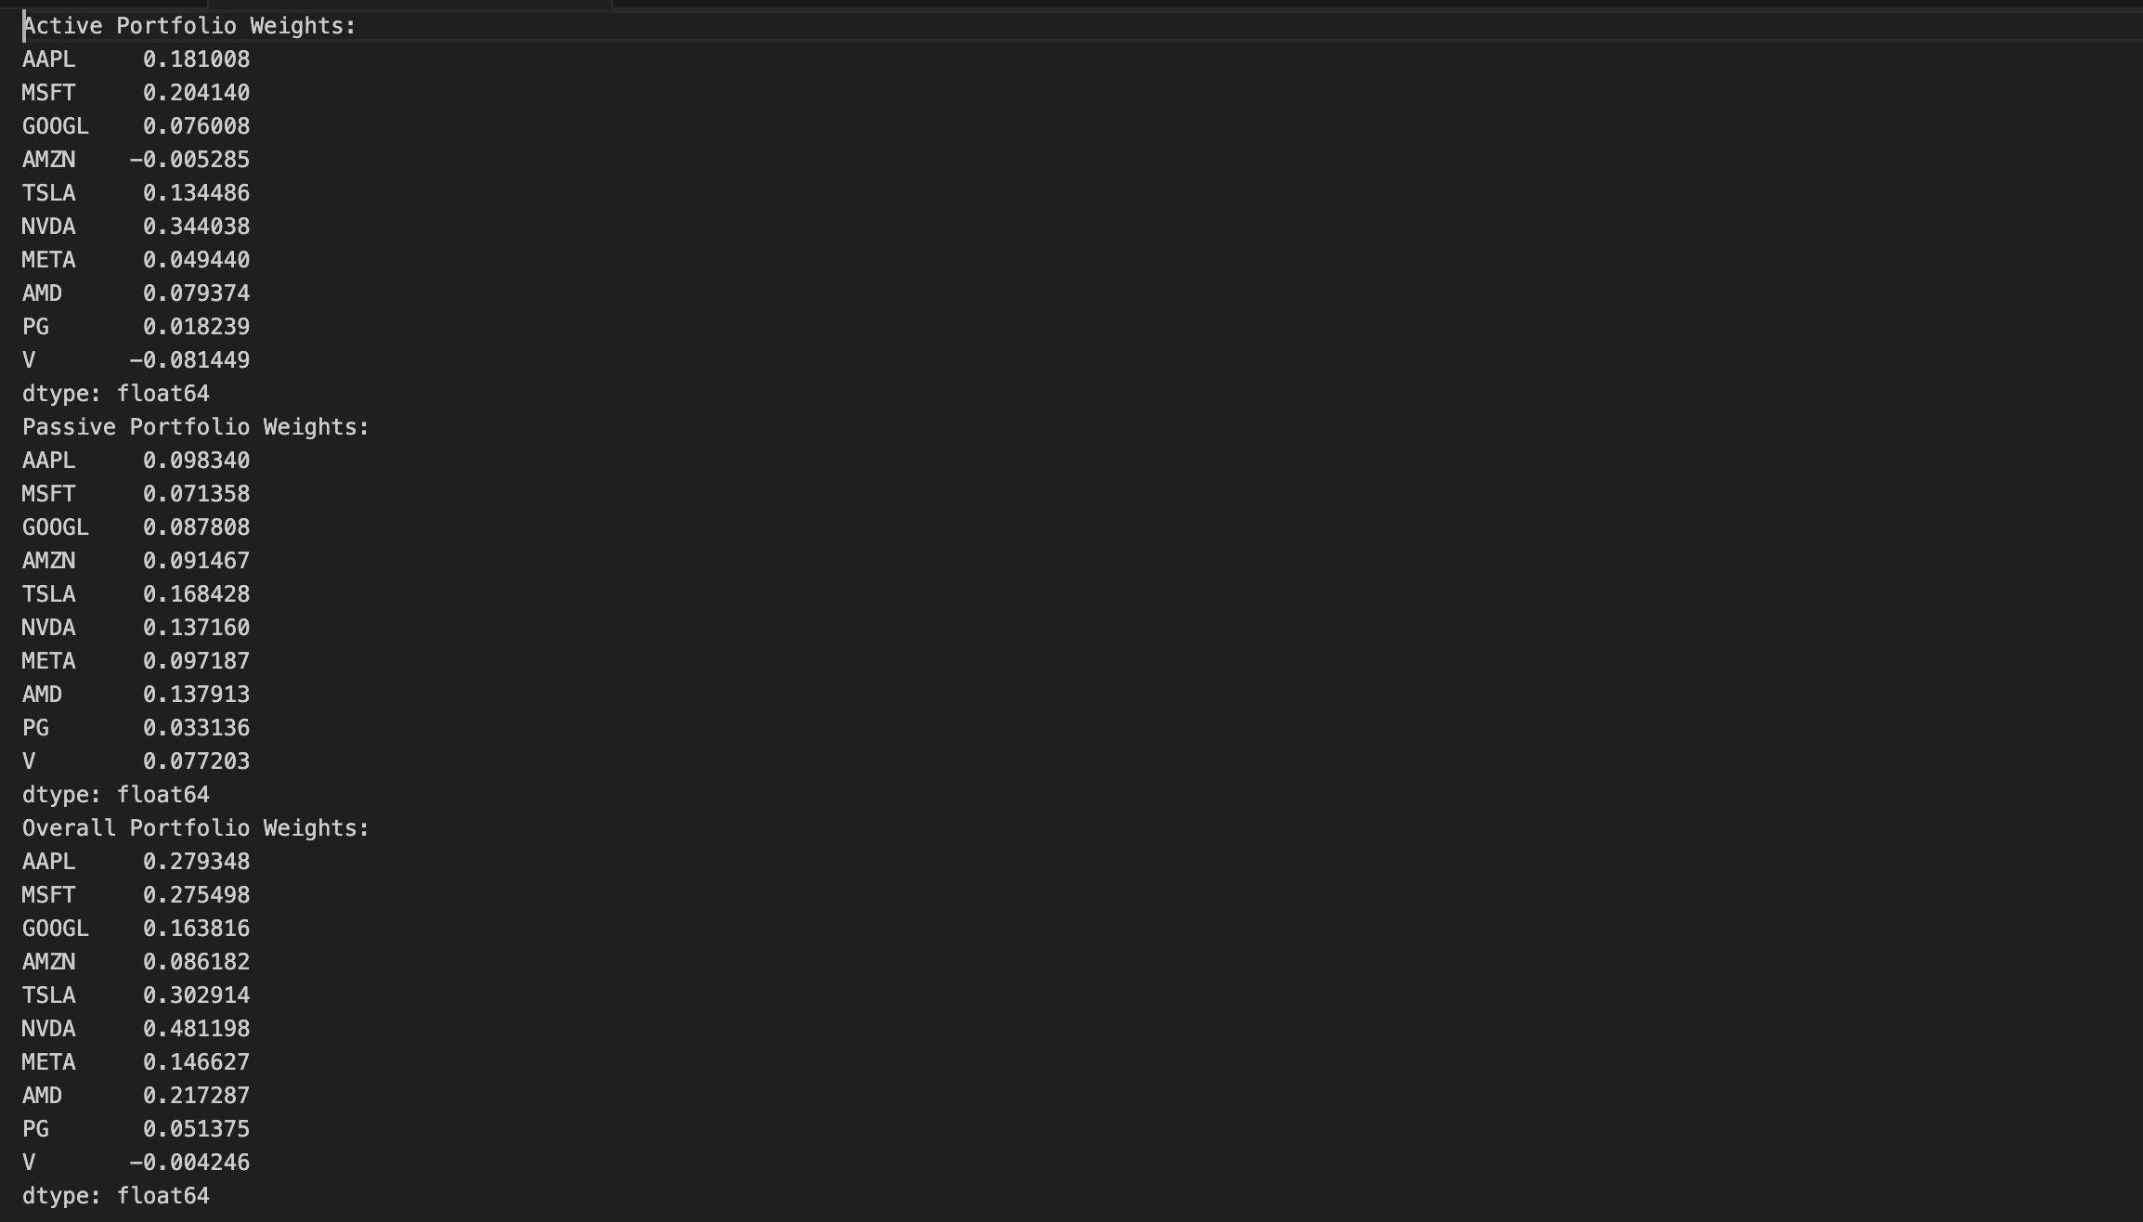
Compute the expected SR of your SIM against that of the SPY. Discuss
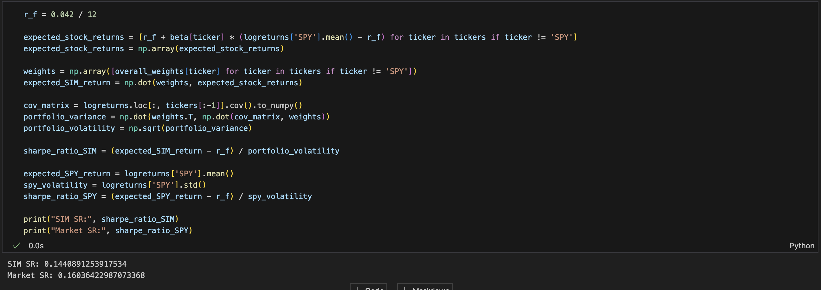
Part 2:
Pick 4 stocks in 2), compute the solution to the problem. You can
either type or submit a hand-written solution (legible!). Make sure you explore all the cases. Once you are done typing the solution, you can provide an excel file with the actual solution for each case, or the computations.

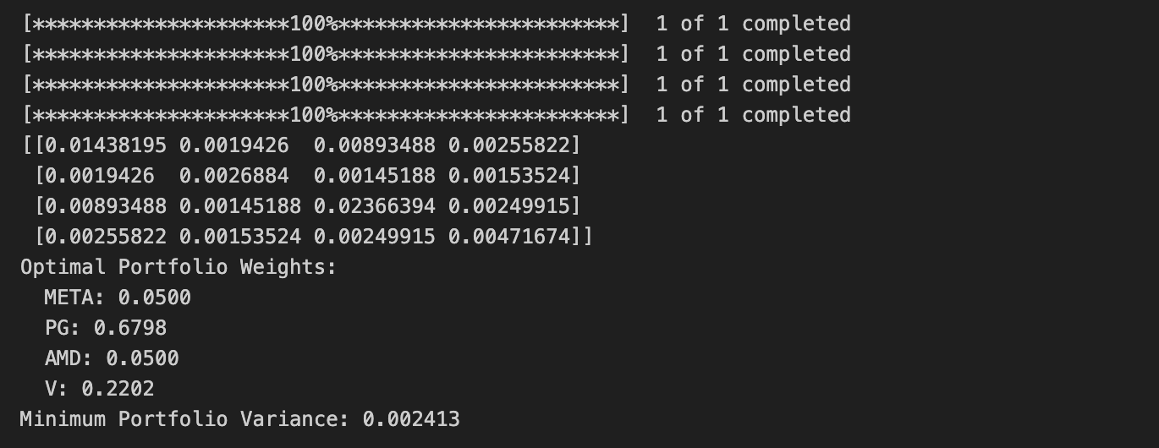


PART 3: Tangent Portfolio
Using the matrix sigma above, and the respective returns, compute the tangent portfolio.
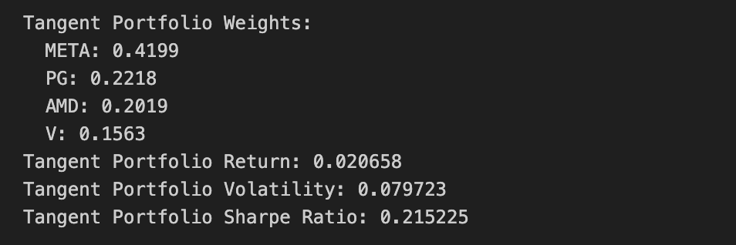
Compute the expected SR of the tangent portfolio. Compare it to 10). Discuss.
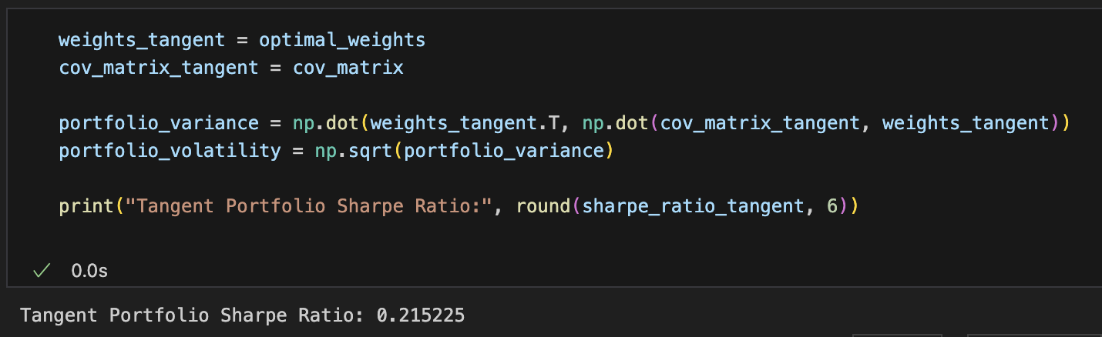
The Sharpe Ratio (SR) of the tangent portfolio, 0.215, is higher than the SIM portfolio's SR of 0.144. This shows that the tangent portfolio has a better risk adjusted return. This means the tangent is more optimized with better wights of assets than the Single Index Model portfolio.
If an investor wants to allocate $10,000 across stocks, compute the amount of margin
required for each investment assuming the investor maxes out the margin loan (i.e., initial margin=50% for all assets). Recompute the SR of the resulting portfolio.

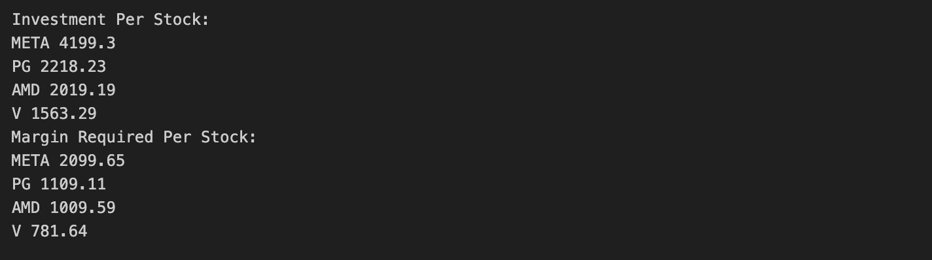

Now assume that the investor sets the initial margin at 75% for any position, even though the requirement is only 50%. Recompute the SR.

